Supplementary Material for Organic & Biomolecular Chemistry
This journal is © The Royal Society of Chemistry 2003

Supplementary data

Electronic Supplementary Information: Dendritic metalloporphyrins with a distal H-bond donor as mimics of haemoglobin
Beatrice Felbera, Carlos Calleb, Paul Seilera, Arthur Schweigerb and François Diedericha
a Laboratorium für Organische Chemie, ETH-Hönggerberg, HCI, CH-8093 Zürich, Switzerland.
b Laboratorium für Physikalische Chemie, ETH-Hönggerberg, HCI, CH-8093 Zürich, Switzerland.

General procedure for iron(II) insertion into the free-base porphyrins 22.2H - 27.2H:
The entire preparation, work-up and characterization of the FeII-porphyrins was done under N2 and rigorous exclusion of air. 10 mg dendritic porphyrin were dissolved in 1 ml THF under N2 and FeBr2 (7.5 eq.) and 10 μl 2,6-lutidine were added. The solution was stirred at r.t. for 2-7 days. After evaporation of the solvent, the resulting red oil was purified by column chromatography on alumina (solvent gradient THF/MeOH 9:1 → 5:3) and provided the pure iron(II) porphyrin.

Typical UV/Vis-spectra of the dendritic iron(II) porphyrins of first dendritic generation before and after addition of 300 eq. dmim:
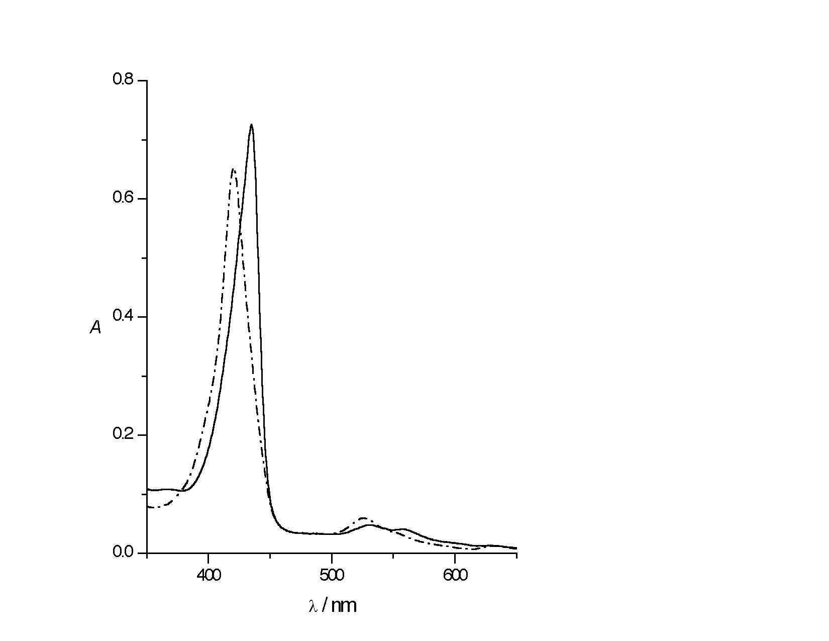
Fig.: The Soret-band of the iron(II) porphyrin 25.Fe(dmim) shifts from 420 nm (- . - .) to 435 nm (⎯⎯) upon addition of 300 eq. dmim.

Characterisations of compounds 5 and 1:

(SP-4-2)-{5,15-Bis[2,6-bis(4-ethoxy-4-oxobutoxy)phenyl]-10-(4,4,5,5-tetramethyl-1,3,2-dioxaborolan-2-yl)porphyrinato(2–)-N21,N22,N23,N24}zinc(II) (5).

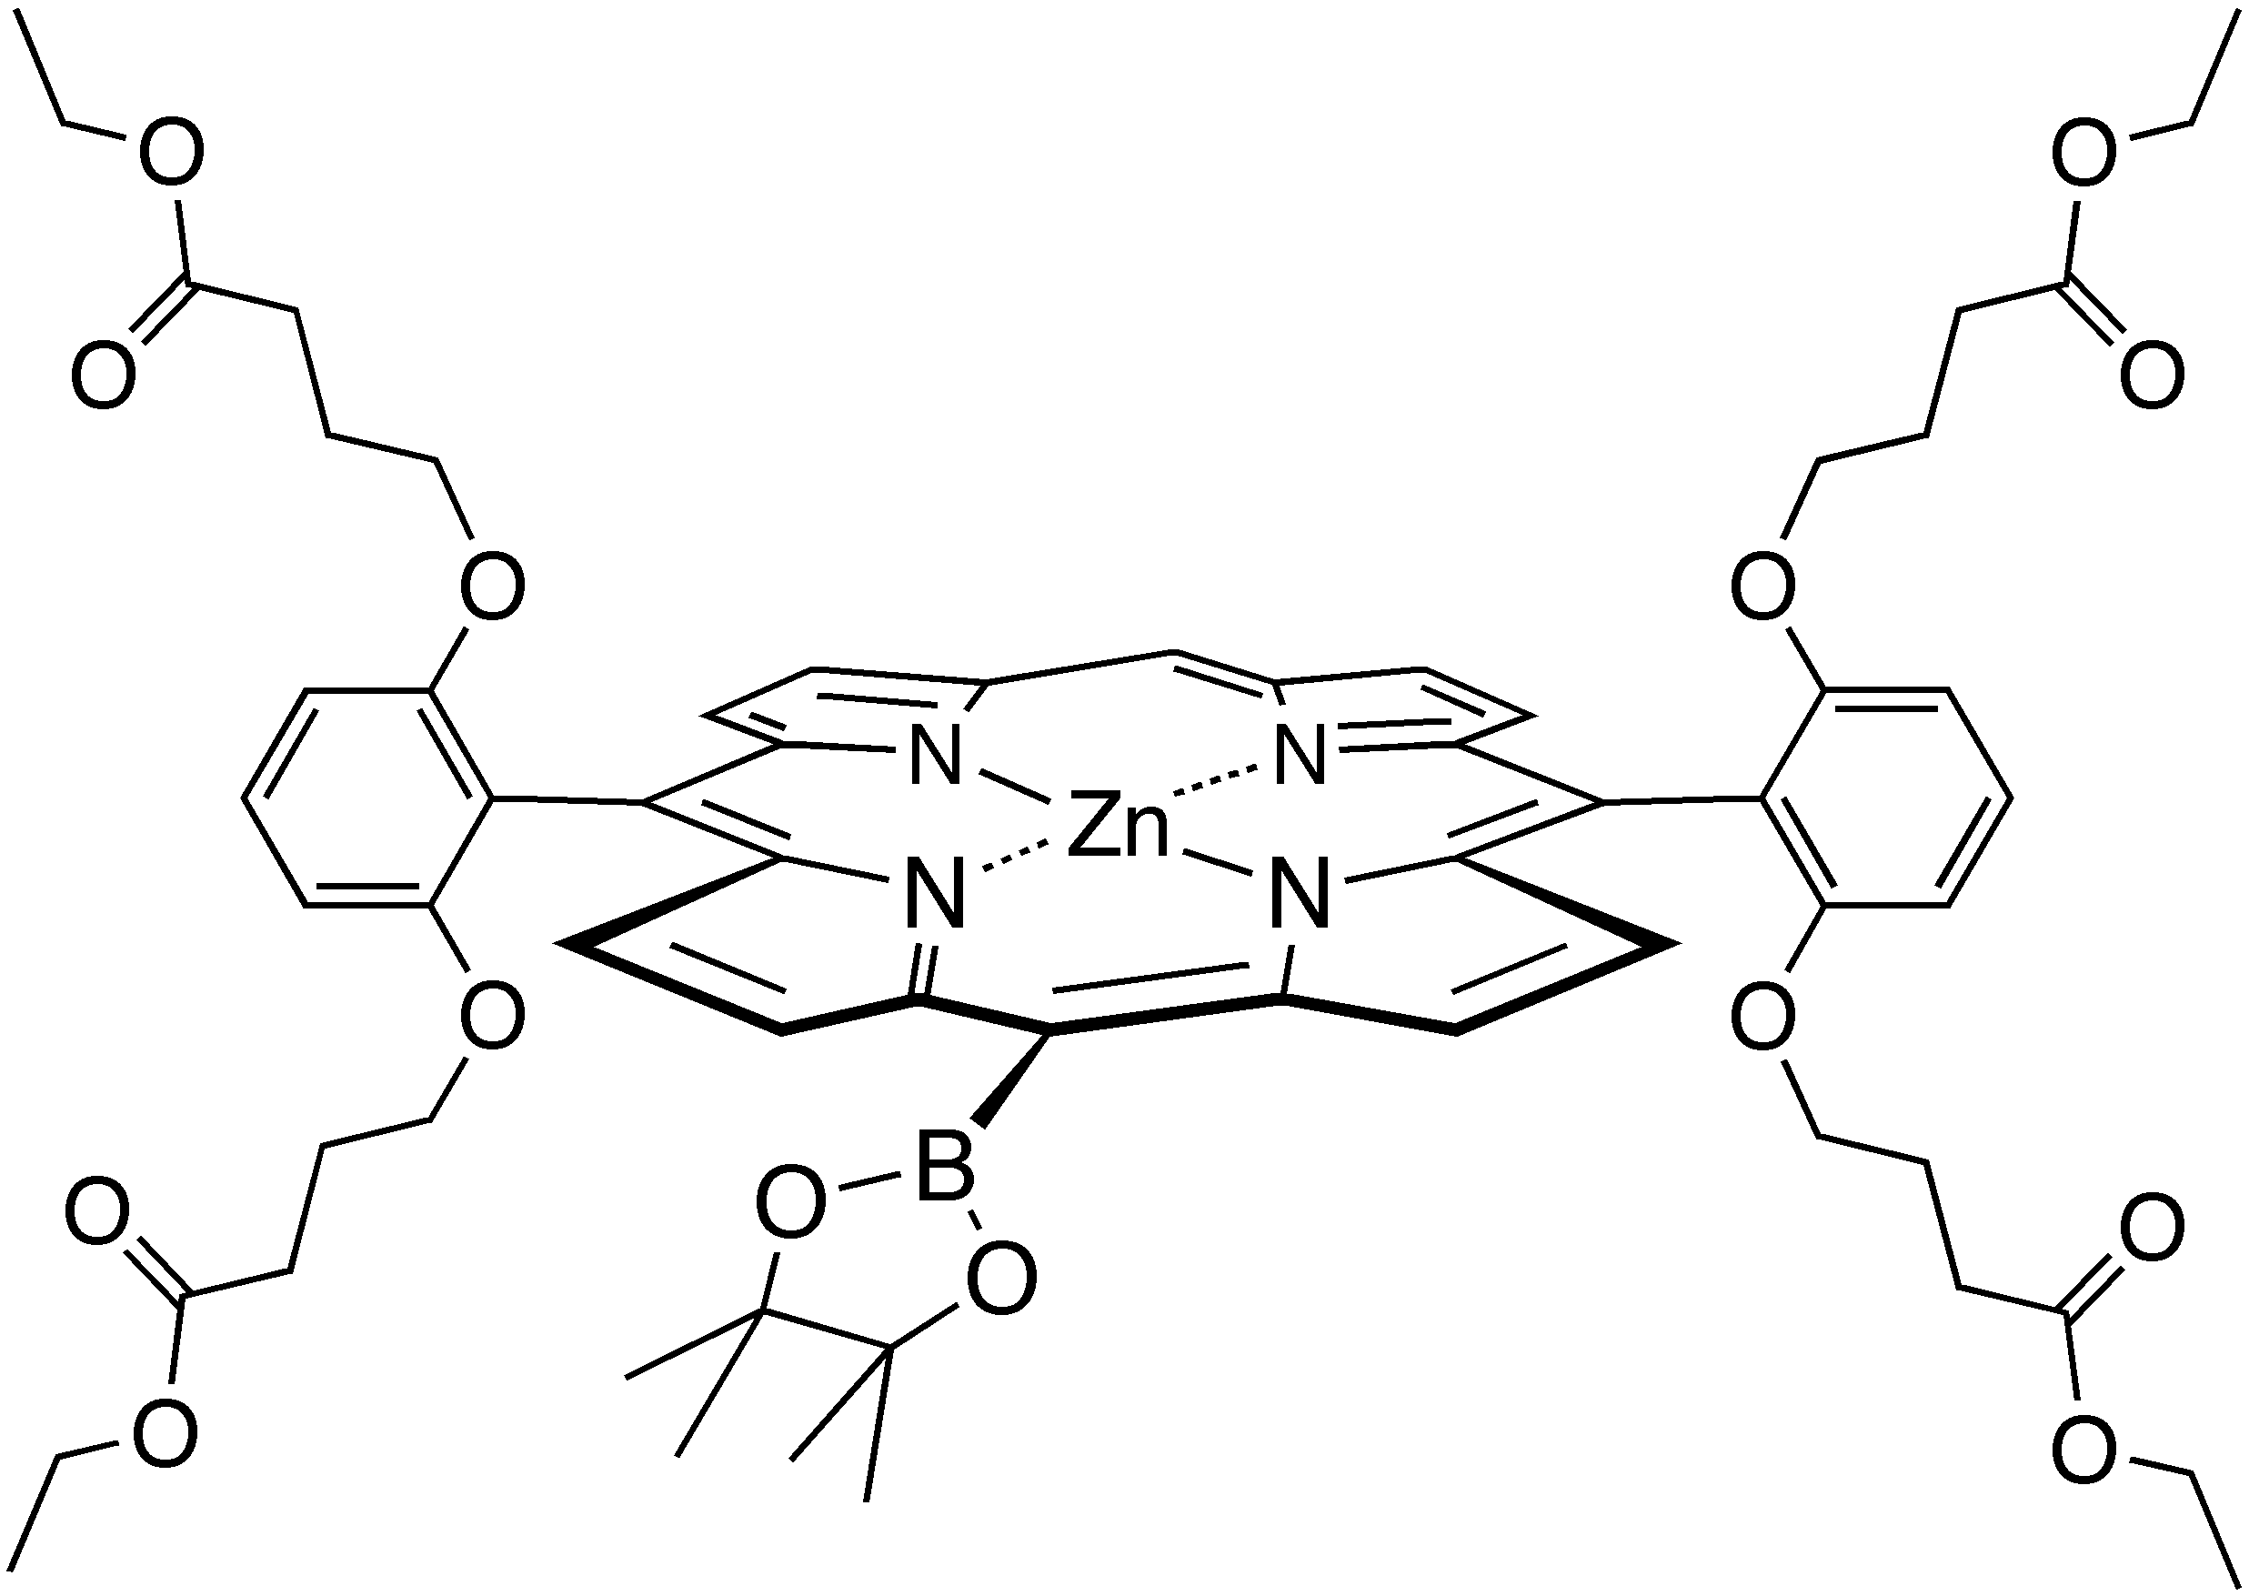
To a degassed solution of 150 mg 3 (133 μmol, 1 eq.), 164 μl 4,4,5,5-tetramethyl-1,3,2-dioxaborolane (145 mg, 1.31 mmol, 8.5 eq.) and 241 μl NEt3 (175 mg, 1.73 mmol. 13 eq.) in 13.5 ml abs. 1,2-dichloroethane, 3 mg [PdCl2(PPh3)2] (4 μmol, 3 mol-%) were added. The solution was refluxed under Ar for 18 h. The reaction was cooled to r.t. and diluted with 20 ml Et2O and 15 ml sat. aq. NaH2PO4 solution. The organic layer was washed with 15 ml H2O and 15 ml sat. aq. NaCl solution. The solvent was removed and the remaining oil filtered through silica gel (solvent Et2O). Recrystallisation afforded 156 mg (quant.) 5.

Pink crystals; mp 117-118 ºC (found: C, 63.4; H, 6.2; N, 5.0. C62H71BN4O14Zn requires C, 63.5; H, 6.1; N, 4.8%); λmax (PhMe)/nm 317 (ε/dm3 mol-1 cm-1 23 200), 403sh (42 800), 423 (574 300), 517 (2 900), 554 (18 800) and 583sh (2 600); vmax(CCl4)/cm-1 2980w, 2876w, 1733s (C=O), 1585m, 1524m, 1456s, 1379m, 1306m, 1248m, 1179s, 1145m, 1103s, 1059m, 996m and 857m; δ_{H}(500 MHz; CDCl₃) 10.15 (1 H, s), 9.83 (2 H, d, J 4.6), 9.30 (2 H, d, J 4.4), 9.00 (2 H, d), 8.95 (2 H, d, J 4.4), 7.71 (2 H, t, J 8.5), 7.05 (4 H, d, J 8.5), 3.88-3.83 (8 H, m), 3.31-3.26 (8 H, m), 1.83 (12 H, s), 1.21-1.14 (8 H, m), 0.99-0.95 (8 H, m) and 0.60 (12 H, t, J 7.1); δ_{C}(75 MHz; CDCl₃) 172.8, 160.0, 153.9, 150.7, 150.3, 148.7, 132.8, 131.8, 131.6, 131.0, 129.9, 122.6, 112.1, 106.6, 106.3, 84.9, 67.9, 59.4, 29.2, 25.2, 23.7 and 13.4, 1 signal is lacking; m/z (HR-MALDI-MS, 2-[(2E)-3-(4-tert-Butylphenyl)-2-methylprop-2-enyliden]malononitrile (DCTB)) 1169.437 (M+, C62H71BN4O14Zn requires 1169.438).

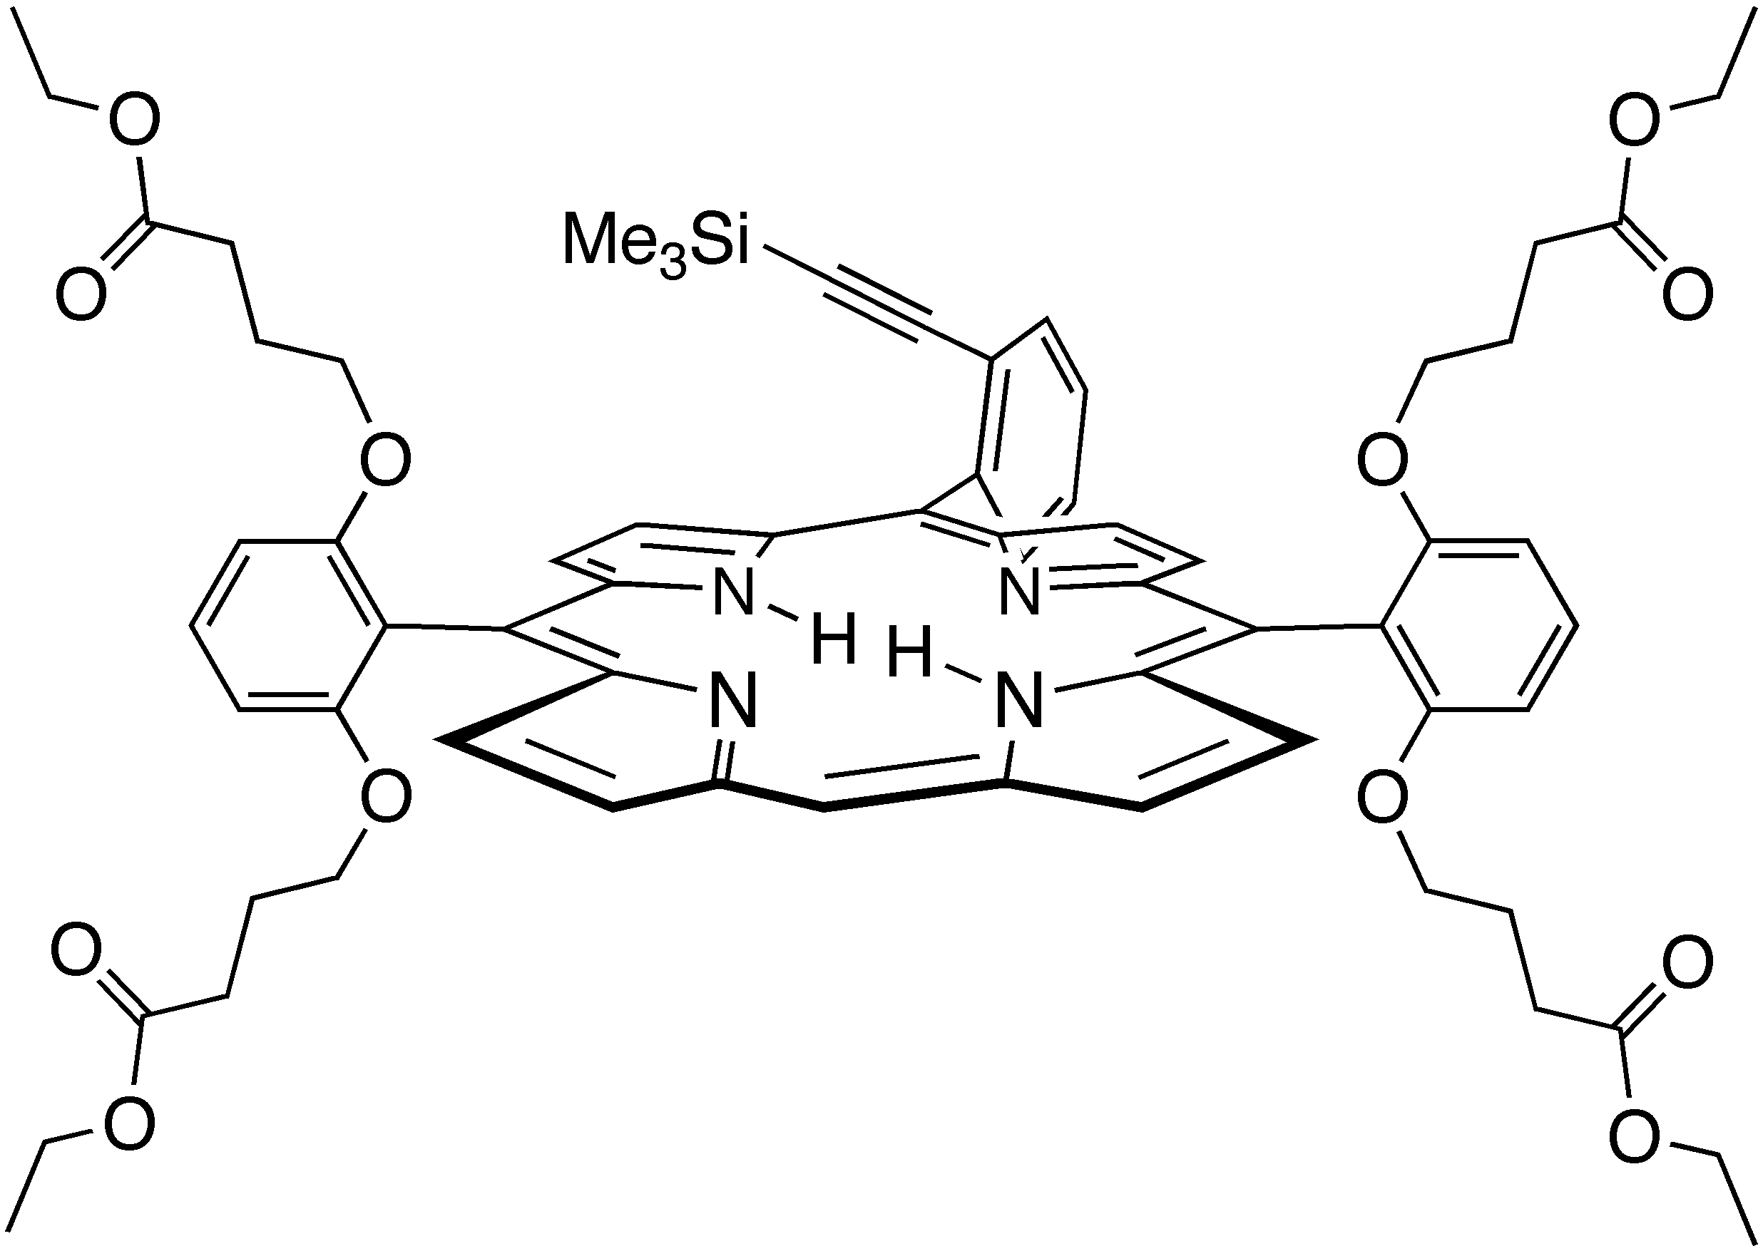
(SP-4-2)-{5,15-Bis[2,6-bis(4-ethoxy-4-oxobutoxy)phenyl]-10-[2-(trimethylsilyl)ethynylphenyl]-porphyrinato(2–)-N21,N22,N23,N24}zinc(II) (1).

Trifluoroacetic acid (1.21 ml) was slowly added to a solution of 731 mg 12 (5.07 mmol, 1 eq.), 3.23 g 13 (10.1 mmol, 2 eq.) and 5.58 g 14 (15.2 mmol, 3 eq.) under N2 in 3 l CH2Cl2. The reaction was stirred 16 h at r.t., and 5.0 g p-chloranil (15.2 mmol, 3 eq.) were subsequently added. The solution was heated to reflux for 2 h and the solvent removed. The residual black oil was filtered through silica (CH2Cl2/EtOAc 9:1) and the pink fraction was isolated. Further purification by column chromatography (SiO2; CHCl3/EtOAc 97:3) afforded 1 (17%) as a highly viscous pink oil.

Pink viscous oil (found: C, 69.7; H, 6.5; N, 4.9. C67H74N4O12Si requires C, 69.6; H, 6.3; N, 4.9%); λmax (PhMe)/nm 370 (ε/dm3 mol-1 cm-1 22 500), 398sh (79 900), 415 (370 800), 508 (18 800), 540 (4 200), 585 (5 600) and 641 (11 000); vmax(CCl4)/cm-1 3315w (H-N), 2980w (C-H), 2959w (CH3), 2940w (CH2), 2876w (CH3), 2161w (C≡C), 1734s (C=O), 1587m, 1457s, 1373m, 1263s, 1249m, 1180m, 1104s, 965w, 957w, 860w and 846w; δ_{H}(500 MHz; CDCl₃) 10.08 (1 H, s), 9.23 (2 H, d, J 4.5), 8.90 (2 H, d, J 4.5), 8.78 (2 H, d, J 4.7), 8.69 (2 H, d, J 4.7), 8.08 (1 H, dd, J 7.5, 1.0), 7.88 (1 H, dd, J 7.9, 1.2), 7.72-7.69 (1 H, m), 7.70 (2 H, t, J 8.5), 7.64 (1 H, dt, J 7.5, 1.2), 7.03 (2 H, dd, J 8.5, 0.6), 7.00 (2 H, dd, J 8.5, 0.6), 3.96-3.85 (4 H, m), 3.87 (4 H, t, J 5.8), 3.70 (4 H, dq, J 7.1, 2.0), 3.62 (4 H, dq, J 7.1, 2.0), 1.52-1.23 (16 H, m), 0.84 (6 H, t, J 7.1), 0.79 (6 H, t, J 7.1), -1.17 (9 H, s), -2.84 (2 H, br s); δ_{C}(125 MHz; CDCl₃) 172.9 (2 ×), 159.8, 159.6, 145.7, 144.7-147.8 (br, 4 ×), 134.9, 131.0-129.8 (br, 4 ×), 131.1, 130.1, 127.7, 126.9, 126.5, 120.3, 117.3, 111.5, 105.4, 105.3 (br, 2 ×), 104.0, 99.2, 67.3 (2 ×), 59.8, 59.7, 29.6 (2 × t), 23.8, 23.7, 13.8, 13.8 and –1.4; m/z (HR-MALDI-MS, DCTB) 1193.485 ([M + K]+); 1177.508 ([M + Na]+); 1155.515 (MH+, C67H75N4O12Si requires 1155.515).

Supplementary Material: EPR spectra
Beatrice Felberª, Carlos Calle^{b}, Paul Seilerª, Arthur Schweiger^{b} and François Diederichª
ª Laboratorium für Organische Chemie, ETH-Hönggerberg, HCI, CH-8093 Zürich, Switzerland.
^{b} Laboratorium für Physikalische Chemie, ETH-Hönggerberg, HCI, CH-8093 Zürich, Switzerland.

In this supplementary material the CW EPR spectra of [22.Co^{II}.dmim] and its oxygenated complex are shown and some preliminary EPR parameters are given.

Sample Preparation and Experimental Details
The dendritic cobalt(II) porphyrin [22.Co^{II}.dmim] was dissolved in toluene (Fluka, puriss., dried over molecular sieves) under an inert atmosphere. The final concentration was about 2 mM. The solution was transferred to an EPR tube which was sealed after evacuation (10⁻⁶ hPa). In order to obtain the oxygenated complex, the sample was exposed to air for 45 minutes.
The X-Band CW spectra were measured on a Bruker ElexSys 500 spectrometer at a microwave frequency of 9.43 GHz using a liquid nitrogen cooling system. The magnetic field was determined by a Bruker ER 035M NMR gaussmeter. The CW EPR spectra were measured at 100 K, with a modulation amplitude 0.2 mT, a modulation frequency of 100 kHz and a microwave power of 6.3 mW.
Data processing was realized in MATLAB (The MathWorks, http://www.mathworks.com). The simulations of the CW EPR spectra were performed using the EPR simulation suite EasySpin (http://www.esr.ethz.ch).
Results
Figure 1 a shows the low-temperature CW EPR spectrum of the non-oxygenated complex [22.Co^{II}.dmim].
Fig. 1 Experimental (a) and simulated (b) X-Band CW EPR spectra of [22.Co^{II}.dmim].

This spectrum is typical for a low-spin cobalt(II) complex with axial ligation to a nitrogen base¹. Preliminary values obtained by simulation: g⎜⎜ = 2.031, g = 2.323, cobalt hyperfine values A⎜⎜ = 232 MHz, ⏐A⏐< 30 MHz.

After the exposure of the solution to air during 45 min at room temperature, the low-temperature CW EPR spectrum changes to a typical spectrum of an oxygenated cobalt(II) complex shown in Figure 2 a.
Fig. 2 Experimental (a) and simulated (b) X-Band CW EPR spectra of oxygenated [22.Co^{II}.dmim].

Preliminary simulation parameters: g1 = 2.0029(±0.003), g2 = 1.987(±0.002), g3 = 2.0737(±0.001), and cobalt hyperfine values A1 = -58.0(±2.0) MHz, A2 = -25.0(±2.5) MHz, A3 = -24.0(±2.5) MHz, β = 70(±10)°.
Here β is the angle between g3 and A3. The above parameters are comparable to those reported earlier for similar complexes².

References
- S. Van Doorslaer, R. Bachmann and A. Schweiger, J. Phys. Chem. A, 1999, 103, 5446.
- S. Van Doorslaer, A. Zingg, A. Schweiger and F. Diederich, ChemPhysChem, 2002, 3, 659.

